Sas vs python
R vs python

Satatistic model

City | Estimated Population
Seattle | 816000
Spokane | 230609
Tacoma | 228202
Vancouver | 198992
Bellevue | 154377
Everett | 113000
Olympia | 55605
Bellingham | 96701
Yakima | 97878
Kennewick | 87549

hese are some of the questions:
- What is your research question and your hypotheses?
- What is the source of your data? Provide a link to your data.
- Does your study answer an acceptable business question using at least one of the statistical methods learned in the program?
- What are your citations from statistical research? What statistical methods did those researchers use?
- Why statistically did they find important?
- Which statistical methods will you use? Normally test, parametric or nonparametric test, post-hoc test.
(Remember you must use one or more of the eight principal statistical methods: t-test, z-test, ANOVA, regression analysis, Kruskal-Wallis, Wilcoxon, Chi-Square, Fisher’s Exact Test.)
- Does the data fit what you are intending to do?
- Which tool(s) will you use? R, Python, SAS. Provide intact citations supporting your choice.
- Has the data been studied statistically by other researchers? If so, what statistical methods did they use? What were their findings?
- What are the limitations and delimitations of your study?
- What are the number of rows of data in your dataset? Min. 7,000 required.
- What is the data sparsity (X)?

Keep in Mind:
- Employers want to see concrete examples of evaluating business problems or cases: predict revenue, predict widgets based on IVs, miles-per-gallon, stock valuation, factors for loan approval, production costs, transportation charges, significant group differences in terms of valuation or market share.
- Social conditions, avocations, or non-business problems are not suitable for Capstone study.
- Must have intact citation per section of your Proposal.
- Limitations are constraints placed upon the researcher. Spell them out.
- Delimitations are constraints the researcher places upon the study. Spell them out.
- The data table is required because it demonstrates to the committee the independent variables (IVs) intended for study as opposed to all IVs.
- Use statistical terminology throughout the proposal. The title should state the principal statistical method being used.
- Cite a study of your subject or similar subject that used the method you are planning to use. (Context and Project Outcome).
- Justification is about what other researchers say about the tool you chose; e.g., R vs. SAS, R vs. Python. It is about expert opinion.
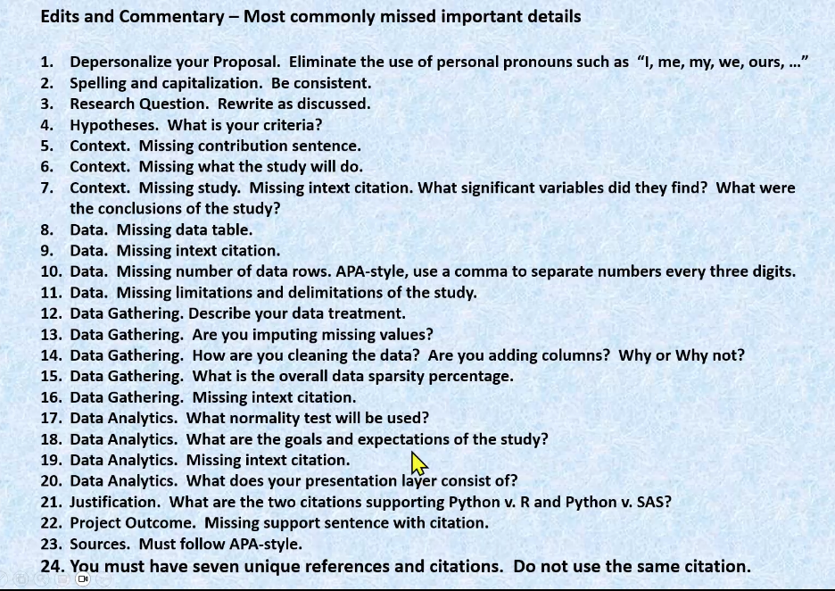

Business problem:
How do weather factors such as temperature, precipitation, wind speed, and air pressure influence daily sales in Seattle?
Regression goal:
- Dependent variable (Y): daily_sales
- Independent variables (X): tavg, tmin, tmax, prcp, wspd, pres, and possibly categorical features like month or season.
Business use case:
Coffee shops can forecast daily revenue based on expected weather conditions to plan:
- Staffing levels
- Inventory management
- Promotions (e.g., hot drinks on cold days, iced drinks on warm days)
Example research question:
Does average temperature and precipitation significantly affect daily sales in Seattle?
- Tool: python
- ML: Scikitlearn (sklearn)
  - Linearregression

I am writing a proposal for a

Hiyab response
Data:
The data required for this study consists of daily sales, date, and store-city location provided by a family member’s restaurant (the “XXX Restaurant” dataset). These core fields will be supplemented by historical weather data (e.g., temperature, precipitation, humidity) retrieved via the Meteostat Python Library / API interface. dev.meteostat.net+3PyPI+3dev.meteostat.net+3 Additionally, city-level estimated population statistics will be incorporated to capture a demand/market-size context variable.
Existing Dataset Description:
The primary dataset includes:
- A series of daily records for the restaurant (one row per day) containing the date of sales, total dollar amount of sales, and the store’s city (or location) identifier.
- After initial receipt of the core dataset, a data-engineering transformation step adds: the daily weather variables (e.g., average temperature, precipitation), and the estimated population for the city on that date (or most recent available). The merged dataset results in a multi-variable table where the response variable is the daily sales dollar amount, and predictor variables include weather features, date/time features (day of week, holiday indicator), city population, and potentially store-location categorical variables.
Data Ownership and Use Permission:
The core restaurant sales dataset is owned by a private individual (a family member), who has granted permission for its use in this academic capstone project. The weather data are retrieved from meteorological open-data sources via the Meteostat API, which offers free historical weather and climate data under appropriate licensing. PyPI+1 Because the dataset is non-human-subject (no personally identifiable customer data) and only involves aggregated sales results for the business, the project remains exempt from human-subjects IRB review per your institution’s guidelines. The permission from the data owner is documented and included in the “Data Engineering Capstone Release Form” as required.
Data Gathering Methodology:
The data gathering process proceeds in the following steps:
- Obtain the daily sales dataset (date, sales amount, and store city) from the family member’s restaurant – this is the base dataset.
- For each record (date + city), query the Meteostat API using the city’s geographic coordinates (or nearest weather station) to retrieve daily weather variables for that date (e.g., average temperature, max/min temperature, precipitation, humidity). dev.meteostat.net+1
- Incorporate estimated city-population figures for each store city (e.g., via publicly available census or city demographic sources) into the dataset as an additional predictor.
- Clean and transform the combined dataset: remove or impute missing values in weather or population fields; ensure consistent date formats; apply categorical encoding (e.g., day-of-week, store city); verify data quality (e.g., check for outlier sales values, missing rows).
- Prepare the final analytic dataset for modelling: verify completeness, apply any necessary normalization or transformation (e.g., log-sales if skewed), split into training and test sets.
Data Analytics Tools and Techniques:
The primary analytical technique will be a multiple linear regression (MLR) model (a type of general linear model) where the response variable is the daily sales amount, and the predictor variables include weather metrics, city population, day-of-week, store location, and possibly other temporal features (holiday indicator, month). Prior to fitting the MLR, exploratory data analysis (EDA) will include: Q–Q plots and Shapiro–Wilk tests to assess normality of residuals or transformed sales; scatter plots and correlation matrices to inspect relationships between predictors and the response; variance inflation factor (VIF) calculations to assess multicollinearity; and possibly stepwise selection or regularisation (e.g., LASSO) to identify the most significant predictors. Model fit will be evaluated via adjusted R², RMSE, MAE, and a hold-out test set to assess prediction accuracy (with the aim of > 70% accuracy under the alternative hypothesis). If any strong non-linear relationships emerge, transformation of predictors or interaction terms may be considered.
Justification of Tools/Techniques:
Multiple linear regression is appropriate for this study because the response variable (dollar-amount of daily sales) is a continuous numeric variable, and the aim is to estimate the linear relationship between multiple predictor variables (weather, population, time features) and sales. The use of Q–Q plots and Shapiro–Wilk ensures the assumptions of linear regression (normality of residuals) are checked. Correlation matrices and scatter plots help assess the linear associations between variables and support the rationale for linear modelling. Additional techniques like stepwise or regularisation ensure that among many candidate predictors the most influential are identified—thus aligning with the research goal of “which variables best predict sales”. Since the dataset is fairly structured (daily data with numeric predictors) and interpretation of coefficients is meaningful for business operations (e.g., for inventory planning, understanding weather-impact on sales), MLR offers both predictive and explanatory utility. Should the relationships show strong non-linearity, transformations or interaction terms within the linear modelling framework still preserve interpretability. The overall approach mirrors best practices in forecasting continuous business outcomes, aligning with your MSDA program objectives.
Project Outcomes and Deliverables:
Key anticipated outcomes and deliverables include:
- A cleaned, integrated dataset combining restaurant daily sales, weather data, and demographic (city population) variables, documented in a data-dictionary.
- An exploratory data analysis report summarising descriptive statistics, correlation analyses, EDA visualisations (scatter plots, Q–Q plots, histograms), and data transformation steps.
- A fitted multiple linear regression model, with estimated coefficients, significance tests (p-values), goodness-of-fit metrics (adjusted R², RMSE, MAE), and VIF or multicollinearity diagnostics.
- A model validation report on hold-out test data, including prediction accuracy (e.g., R² on test set, RMSE), and evaluation relative to the hypothesis (specifically whether model accuracy > 70% is achieved).
- A business-insight summary document, translating the modelling results into actionable recommendations for the restaurant (e.g., how inventory planning could consider weather or population trends, how strong predictor variables inform operational strategy).
- A technical appendix (code files, scripts in R/Python/SAS, documentation of data-gathering process, release form for data use, versioning and reproducibility notes) suitable for the MSDA capstone review and future reuse.

Context: Explain why the situation or question would benefit from data analysis in less than 500 words. Click here to enter text.

Data: Identify data you will need to collect that is relevant to the situation or question. Click here to enter text.
If an existing dataset will be used, describe the dataset. Click here to enter text.

Explain who owns the data and why you are allowed to use this data for your capstone project. Click here to enter text.

Note: If you are using restricted information, please have the Data Engineering Capstone Release Form signed by an authorized agent on behalf of the data owner. The data owner’s legal name is required on the form.
- The data needed to be collected for the question is the publicly available information provided by the Small Business Administration for Paycheck Protection Program loan recipients in the state of New York, U.S. (Department of the Treasury, 2020). The data set before removing these records contains 391,790 rows.
- The data set is made available through the Small Business Administration. The data set includes the following vital data: a) borrower, including the business type (organization type, veteran status, relationship with lender and the gender and race target variable loan amount. The predictor variables are broken down as follows:
- https://home.treasury.gov/policy-issues/care-act/assistance-for-small-businesses/sba-paycheck-protection-program-loan-level-data
- The Small Business Administration has made this information publicly available. There is no small data set in this industry because the program represents 661M loan recipients and 4.9M loans only contains firms below $150,000. Additionally, all fields were not required by the SBA or certain organizations, meaning some data elements are missing depending on borrower. According to the Department of Treasury (2020), “these loans are intended to keep small businesses operating, keep workers on the payroll and help the economy recover from the pandemic.” Since not all information was required at the time of the Application, this means not every variable used has the same number of rows to build a properly structured data set. However, a sufficient number of rows are available to provide a reliable analysis of the response Model.
Data Gathering: Describe the data-gathering methodology you will use to collect data.
  - The Treasuries’ Office of Data PPA will be downloaded as published in the SBA CSV File from the website referenced above. The data set variable observed is $150,000 and below in sales only for New York State (excluding missing data). The variables will be defined by the business type, gender, veteran status, relationship with the lender, and race with the response variable being the loan amount. The predictor variables will be used to identify which significantly affect the response variable. Some of the data that will be removed includes missing data, incomplete fields, or invalid data entries. The predictor variables will be verified. Overall data quality was at 97%— meaning that 3% of the data contained missing values but removed.
Data Analytics Tools and Techniques: Identify the appropriate data-analysis technique you will use to analyze this data.
  - The Design of the Study: I. A Q-Q Plot and Shapiro-Wilk were run to determine if the data were normal. 2. A Generalized Linear Model which chose not to reject the Model for normality (Linear Model). Scatter plots displayed the predictor and response variable to test correlation between the response and the predictor variables. After verifying the confirmation of predictor variables, correlation was used to determine the relationship strength between predictor variables and the dependent variable (Kutner et al., 2005). Descriptive and inferential analysis were performed (categorical and continuous data) to test the data structure between variable types. Both descriptive and advanced analysis were used for best fit representation.
Justification for Tools/Techniques: Explain why the data-analysis technique you chose is an appropriate technique to analyze the data collected.
  - SAS will be used for the creation of the regression model for the data. According to Tashakkori & Teddlie’s (2017) SAS software Python can be slightly easily adaptable and more user friendly. The Model chosen allows testing of the hypothesis (reject or accept the null) for all potential amounts based on the composition of a modeling company. Support for the alternative hypothesis from Tashakkori (2017) a multiple linear regression model will be required for testing and estimating the target variable by determining the strength of predictor variables with respect to loan data.

Click here to enter text.

